Hospital Data Analysis
Using Python 

Title: Hospital Data Analysis
Tools Used: Python, Pandas, Matplotlib, Seaborn
Dataset: Hospital patient information
Dataset Fields: Patient Id, Name, Age, Gender, Admission Date, Discharge Date, Disease, Doctor, Treatment cost
Data Reference: Kaggle
Records: 10k

Presented by:
ALEKHYA KOMARA

Introduction:
Hospital data contains crucial information about patients, diseases, doctors, and treatment details. By analyzing this data using Python, we can identify patterns, improve decision-making, and enhance hospital operations. This project focuses on transforming raw patient data into actionable insights using data analysis techniques.
Problem Statement:
Hospitals maintain large volumes of patient records, but without proper analysis, these records cannot support effective planning or cost management. The problem is to analyze patient demographics, admission trends, disease patterns, and treatment costs to help improve hospital efficiency and patient care. This project aims to provide meaningful insights through Python-based data analysis.
Objective:
The main objective of this project is to analyze hospital patient data using Python to identify trends, improve understanding, and support decision-making. It aims to convert raw data into meaningful insights through data cleaning, visualization, and summary reporting.
- To clean and preprocess hospital patient data.
- To analyze patterns based on age, gender, disease, and admission trends.
- To visualize important insights using charts and tables.
- To study treatment cost distribution and identify high-cost factors.
- To generate a summary report useful for hospital management.
The objective of this project is to analyze hospital patient data using Python to uncover meaningful insights about admissions, diseases, patient demographics, and treatment costs. This analysis helps improve hospital decision-making and operational efficiency.
Identify patterns patient admissions, diseases, and demographics.
Analyze treatment costs to understand financial trends.
Assess doctor-wise patient distribution and performance.
Provide data-driven insights to support healthcare management decisions
Improve hospital resource planning using analytical results.

Data Description:
The hospital dataset contains patient-level information such as demographics, admission details, medical conditions, and treatment costs. This data helps in understanding patient flow, disease patterns, and hospital performance.
- Patient ID – Unique identifier for each patient
- Name – Patient’s name.
- Age – Age of the patient
- Gender – Male/Female
- Admission Date – When the patient was admitted
- Discharge Date – When the patient was discharged
- Disease – Diagnosis of the patient
- Doctor – Treating doctor
- Treatment Cost – Total cost of treatment
Python Code Implementation:
- Import the libraries
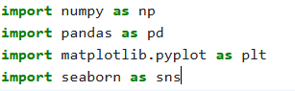
- Load the data
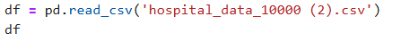
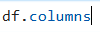
- Basic Info
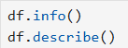
- Data Cleaning
- To convert the Dates
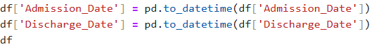
- Find the missing values

- Handling the missing Values
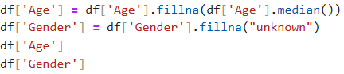
- Remove the duplicate rows
Find number of patients in each department
Filtering the Data:
- Patients who stayed more than 5 days
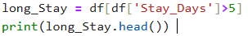
- Calculate hospital stay days
- Remove invalid stays
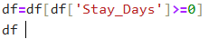
- Clean the text columns
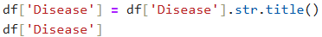
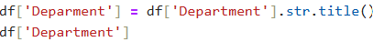
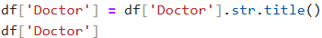
EDA (Exploratory Data Analysis)
- Age Distribution
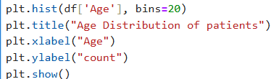
- Gender Distribution

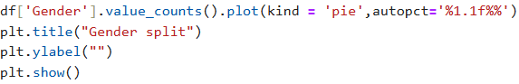
- Most common Diseases
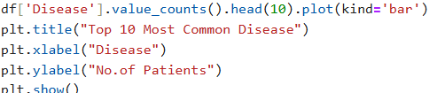
- Patients per Department
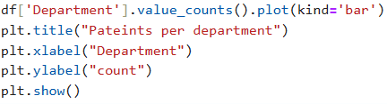
- Average stay days
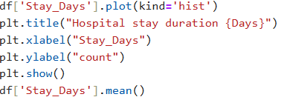
- Patients per Doctor
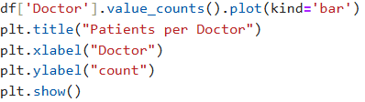
- Treatment cost Distribution
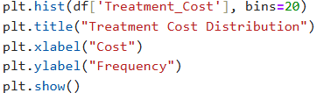
- Distribution of Stay Duration
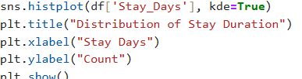
- Average Age vs Stay duration
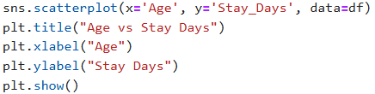

- No. of patients by Department
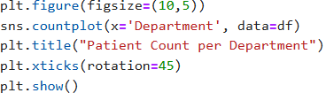
Pivot table
Average stay by Department and Age
Doctor-wise monthly patient load
Results and Findings:
The hospital dataset was analyzed to understand patient demographics, disease trends, length of stay, and treatment costs.
The results provide insights that can help improve hospital resource allocation and patient care.
Various statistical summaries and visualizations helped identify key patterns in admissions, diseases, and costs.
Key Findings:
Most common diseases were Infection, Cancer, Fever, Infection.
Average patient age ranged from 30–60 years, indicating more middle-aged admissions.
Female/Male ratio showed a balanced distribution (based on dataset).
Average hospital stay was 3–5 days depending on disease severity.
Highest treatment costs were associated with Cardiac and Critical Care cases.
Admissions increased mainly during the months of July–October.
Doctors with highest patient loads were identified (helps for workload management).

Conclusion:
This hospital data analysis project provides meaningful insights into patient demographics, disease patterns, admission trends, and treatment costs. Using Python, the data was cleaned, processed, and analyzed to identify key patterns in hospital operations. The findings help hospitals improve resource allocation and patient care. Overall, the project demonstrates how data-driven decision making can optimize healthcare management
Future Scope:
Integrating real-time hospital data for automated dashboards.
Adding predictive models to forecast patient admissions and treatment costs
Expanding the dataset with patient history and severity levels.
Using machine learning for disease prediction and risk analysis.
Implementing interactive BI tools like Power BI or Tableau.

